COS30017 Assignment 2
  - Mark Saleh 103994313
Assignment 2 for COS30017 is a proof-of-concept application for a musical instrument renting company. It allows the user to view three instruments: a guitar, a drum set and a piano, comparing their prices and ratings. If they choose to borrow one, they can then select the instrument's colour, type, or manufacturer using radio buttons and then purchase them. The application also keeps a money variable that depletes with every purchase, and will not allow the user to purchase instruments without enough money.

UI/UX
Before beginning work on the UI, two sketches were made in Figma to plan the layout for the app screens. One of them (Figure 1) was for the main activity, and the other (Figure 2) was for the rent activity.
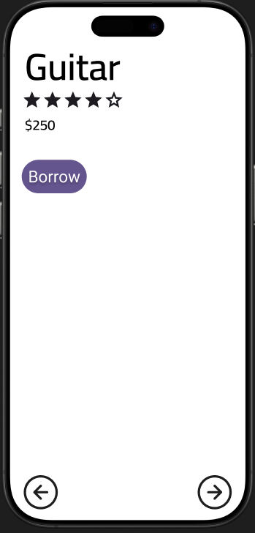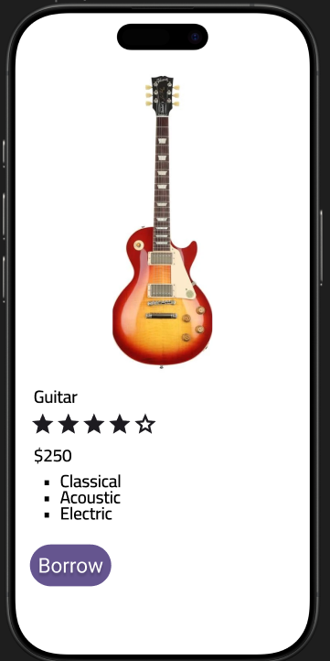
Figures 1 and 2: The planned layouts for MainActivity and RentActivity
It was noticed that the required widgets would include ImageView, TextView, RatingBar, Button and RadioGroup. However, these plans were subject to change. For example, the instrument's image was originally only going to appear in the rent activity, but it was deemed more aesthetically pleasing and helpful to the user to have it in both menus. The arrow buttons were also replaced with a "Next" button to comply with the assignment's instructions, and a selector for the duration was added. Figures 3 and 4 show the final result:
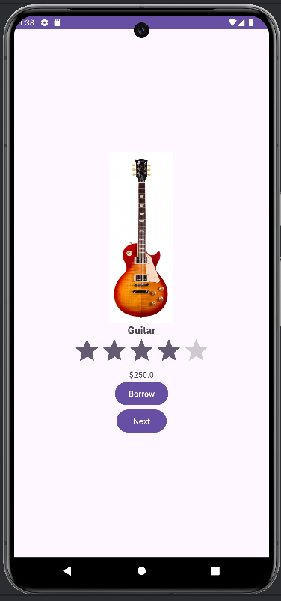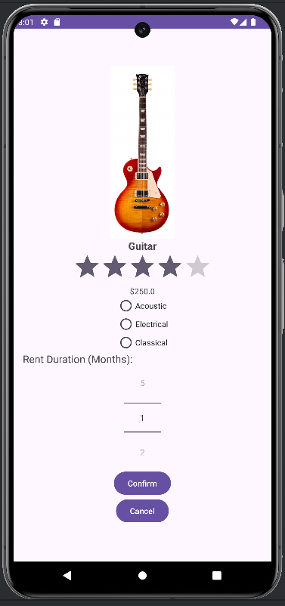
Figures 3 and 4: The final UI of the application
The application offers three instruments: guitar, drums and piano. The code is designed dynamically so that more can easily be added. Each instrument can be displayed in MenuActivity or RentActivity. Therefore, the following six screenshots (Figures 5-10) show all the possible screens in the application:
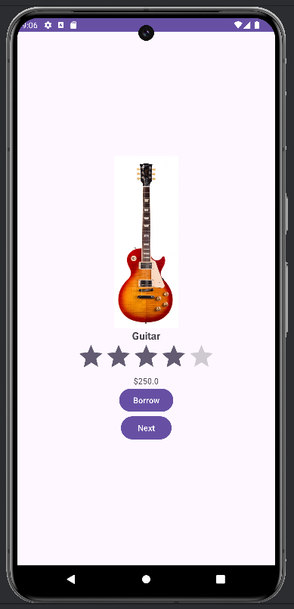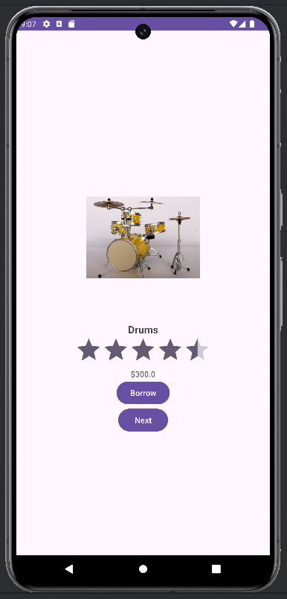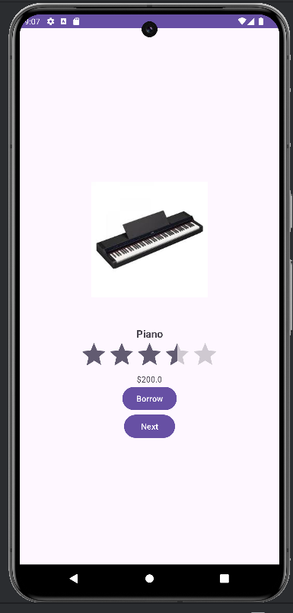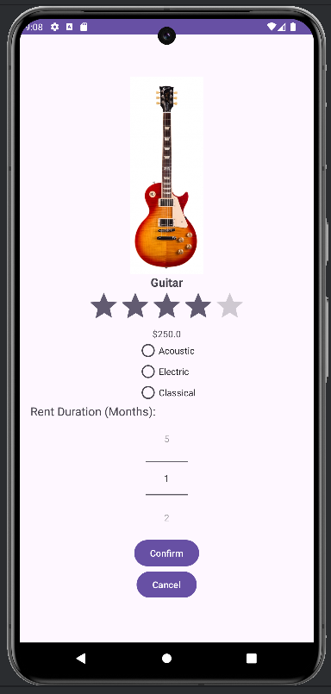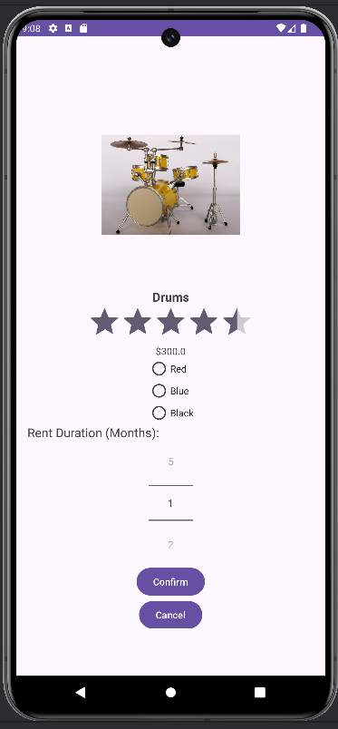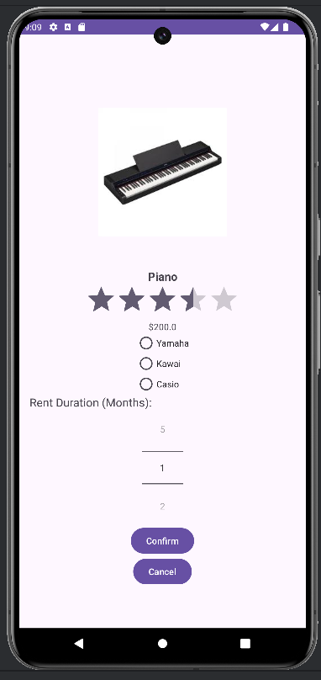
Figures 5-7 (above): All three instruments as shown in MainActivity
Figures 8-10 (below): All three instruments as shown in RentActivity
Four layout files were used: activity_main.xml, activity_main_land.xml, activity_rent.xml and activity_rent_land.xml. While the portrait layouts use LinearLayout, the horizontal layouts use ConstraintLayout and place the image on the side, which makes the screen more balanced. Figures 11-16 all six screens in ConstraintLayout:
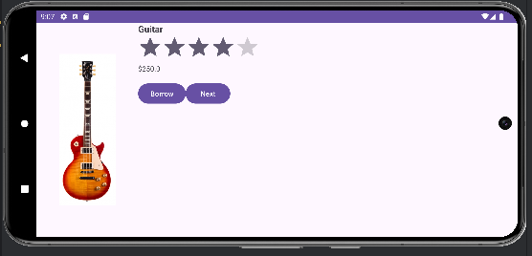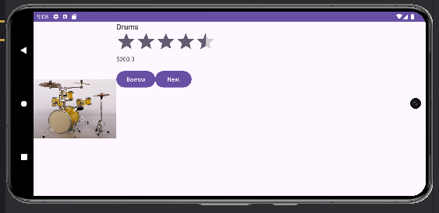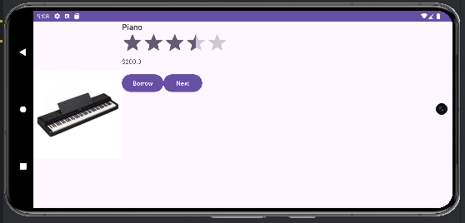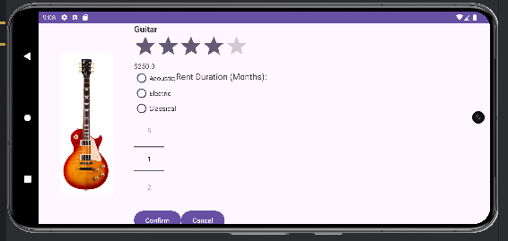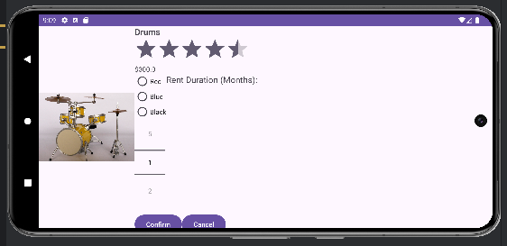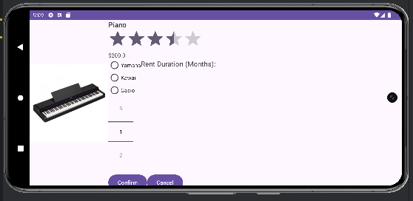
Figures 11-16: The horizontal layouts
Additionally, a Japanese strings file was added, which allows the application to display text in Japanese too. Figures 17-20 show the MainActivity screen as well as all three RentActivity screens in Japanese.
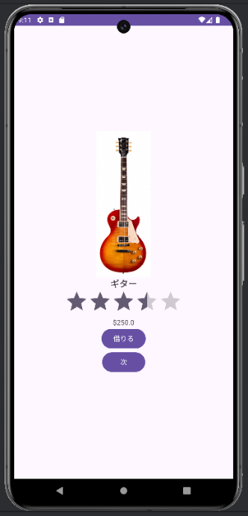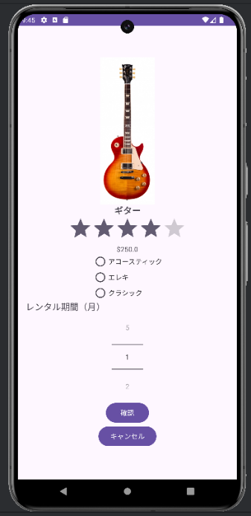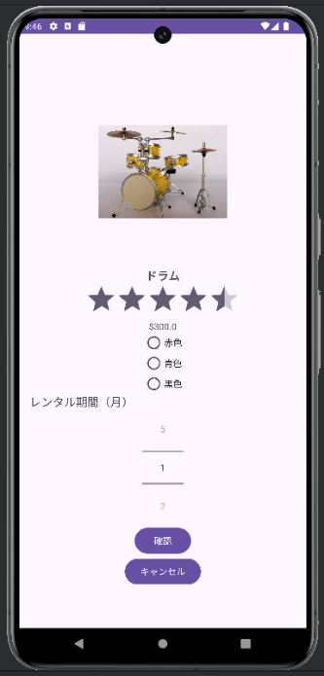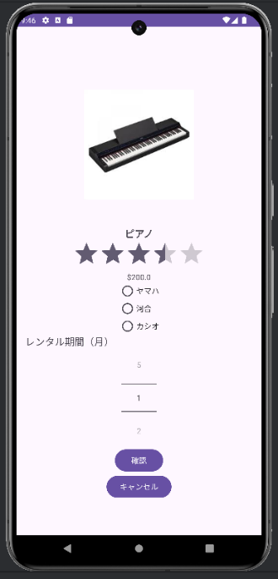
Figures 17-20: Screenshots of the application in Japanese
Toasts are also used to inform the user whenever their booking is cancelled or confirmed, and display their updated balance after a purchase. Figures 21-23 demonstrate this:
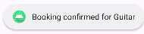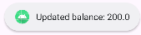
Figures 21-23: Toast messages
These design choices were guided by research, especially using the Android Developers website,^{[1]} which was greatly helpful with coding too. One of the design principles used was the implementation of a NumberPicker for the months, as opposed to a simple text input, which based on articles like this one^{[2]} are less intuitive for users. The choice to use Toasts instead of Snackbar was influenced by research suggesting that Snackbars are interactive whereas Toasts are not.^{[3]} User interaction is not necessary in this scenario, so Toasts seemed more appropriate.

Use Cases
Below are two user stories to illustrate how this application might be used. User 1 is a music enthusiast who wants to browse through the available instruments and compare their prices and ratings. User 2 is a customer who wants to use an electric guitar for a music project, while staying within budget. Their respective use cases are as follows:

Use Case 1
User 1 opens the app and browses through the available instruments. He clicks "Borrow" to see more information about the instruments, including possible customisations, and briefly considers buying one, but then cancels his booking. A toast appears, informing him that his booking was cancelled.

Use Case 2
User 2 opens the app, navigates to the guitar and selects "Borrow". In the next menu, he uses the radio buttons to select an electric guitar, selects 1 month for the duration, and clicks "Confirm". A toast appears, informing him that his order was confirmed. The guitar is prepared for him at the shop, to which he drives and picks it up.

Functionality
The core functionality of the application is the selection and renting of musical instruments. The user can cycle through the available instruments by pressing "Next". When they have found the right type of instrument, they can choose "Borrow", which leads them to the RentActivity. Here, they can customise the type, colour or manufacturer of the instrument, and either confirm their booking or cancel it and return to the main menu. Pressing the back button also counts as a cancel.
One core feature is a variable named "money". This starts at $1000, and depletes with every purchase. The amount subtracted from it is the monthly price of renting an instrument multiplied by the number of months it is rented for. When it reaches $0, the application no longer allows the user to rent instruments, instead displaying an error Toast (Figure 24).
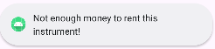
Figure 24: The error Toast that displays when the user runs out of money
Testing was performed both manually and using Espresso. This resulted in some bugs being discovered. For example, a user can refill their money by rotating the screen. Another error was that, in Japanese, the radio buttons would not display properly. The cause of that error was resolved: it was that the case switch handling the radio buttons used hardcoded string values ("Guitar", "Drums", "Piano") instead of the strings file (getString(R.string.guitar), getString(R.string.drums), getString(R.string.piano)). Three Espresso tests were used to confirm that elements appear, buttons work and ratings display correctly, all of which have passed (Figure 25). As specified in the instructions, the code was edited to remove redundancy.
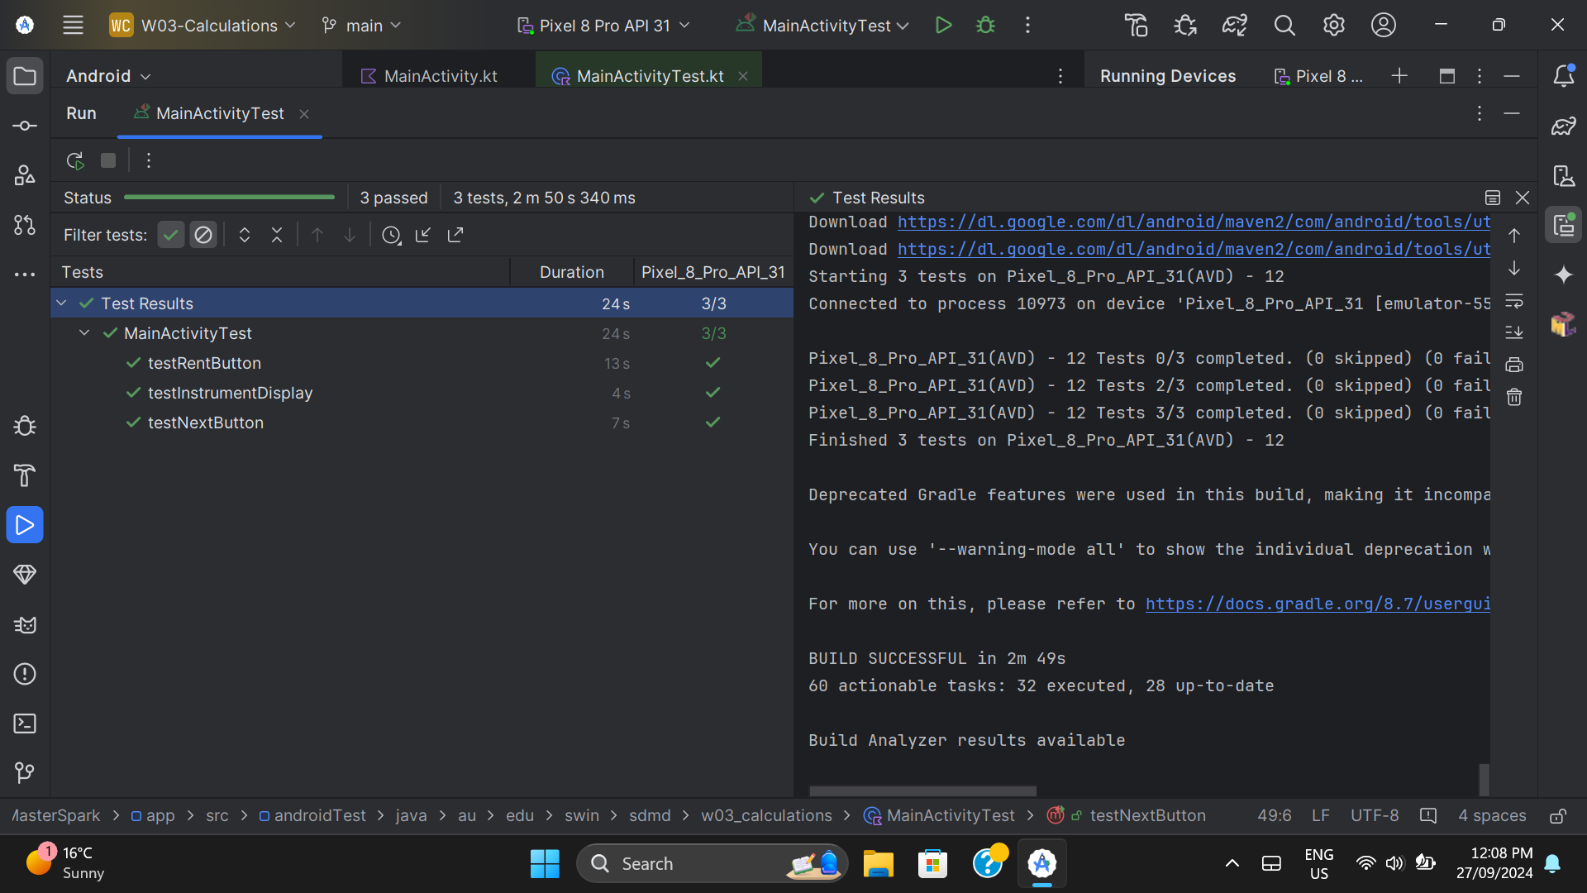
Figure 25: A screenshot of the Espresso tests passing

Code Quality
Below is MainActivity.kt:
package au.edu.swin.sdmd.w03_calculations
import android.content.Intent
import android.os.Bundle
import android.os.Parcel
import android.os.Parcelable
import android.os.Parcelable.Creator
import android.view.View
import android.widget.Button
import android.widget.ImageView
import android.widget.NumberPicker
import android.widget.RadioButton
import android.widget.RadioGroup
import android.widget.RatingBar
import android.widget.TextView
import android.widget.Toast
import androidx.appcompat.app.AppCompatActivity
// Data class for Instrument
class Instrument : Parcelable {
// Properties
var name: String?
private set
var rating: Float
private set
var price: Double
private set
var imageResource: Int
private set
// Constructor
constructor(name: String?, rating: Float, price: Double, imageResource: Int) {
this.name = name
this.rating = rating
this.price = price
this.imageResource = imageResource
}
// Private constructor for creating Instrument from Parcel (used in Parcelable)
private constructor(`in`: Parcel) {
name = `in`.readString()
rating = `in`.readFloat()
price = `in`.readDouble()
imageResource = `in`.readInt()
}
// Describe contents (required for Parcelable)
override fun describeContents(): Int {
return 0
}
// Writes Instrument data to a Parcel for passing between activities
override fun writeToParcel(parcel: Parcel, i: Int) {
parcel.writeString(name)
parcel.writeFloat(rating)
parcel.writeDouble(price)
parcel.writeInt(imageResource)
}
// Companion object
companion object CREATOR : Creator<Instrument> {
override fun createFromParcel(parcel: Parcel): Instrument {
return Instrument(parcel)
}
override fun newArray(size: Int): Array<Instrument?> {
return arrayOfNulls(size)
}
}
}
// Activity for renting an instrument
class RentActivity : AppCompatActivity() {
private var rentImage: ImageView? = null
private var rentName: TextView? = null
private var rentRating: RatingBar? = null
private var rentPrice: TextView? = null
private lateinit var instrumentOptions: RadioGroup
private lateinit var monthPicker: NumberPicker
private var money = 0.0
override fun onCreate(savedInstanceState: Bundle?) {
super.onCreate(savedInstanceState)
setContentView(R.layout.activity_rent)
// Initialize
rentImage = findViewById(R.id.rent_image)
rentName = findViewById(R.id.rent_name)
rentRating = findViewById(R.id.rent_rating)
rentPrice = findViewById(R.id.rent_price)
instrumentOptions = findViewById(R.id.instrument_options)
monthPicker = findViewById(R.id.month_picker)
// Set the month picker range from 1 to 5
monthPicker.maxValue = 5
monthPicker.minValue = 1
// Get the selected instrument and user's money from the intent
val selectedInstrument = intent.getParcelableExtra<Instrument>("selectedInstrument")
money = intent.getDoubleExtra("money", 1000.0)
// Display the selected instrument details
if (selectedInstrument != null) {
rentImage?.setImageResource(selectedInstrument.imageResource)
rentName?.text = selectedInstrument.name
rentRating?.rating = selectedInstrument.rating
rentPrice?.text = "$" + selectedInstrument.price
// Populate radio group
instrumentOptions.removeAllViews()
when (selectedInstrument.name) {
getString(R.string.guitar) -> {
addRadioButton(getString(R.string.acoustic))
addRadioButton(getString(R.string.electric))
addRadioButton(getString(R.string.classical))
}
getString(R.string.drums) -> {
addRadioButton(getString(R.string.red))
addRadioButton(getString(R.string.blue))
addRadioButton(getString(R.string.black))
}
getString(R.string.piano) -> {
addRadioButton(getString(R.string.yamaha))
addRadioButton(getString(R.string.kawai))
addRadioButton(getString(R.string.casio))
}
}
} else {
// Error message
Toast.makeText(this, "Instrument not found!", Toast.LENGTH_SHORT).show()
}
// Confirm button
findViewById<View>(R.id.confirm_button).setOnClickListener { _: View? ->
if (selectedInstrument != null) {
// Calculate the total price for the selected months
val months = monthPicker.value
val totalPrice = selectedInstrument.price * months
// Check if the user has enough money to rent the instrument
if (money >= totalPrice) {
money -= totalPrice
Toast.makeText(this, "Booking confirmed for " + selectedInstrument.name, Toast.LENGTH_SHORT).show()
// Return the updated money balance to MainActivity
val resultIntent = Intent()
resultIntent.putExtra("updatedMoney", money)
setResult(RESULT_OK, resultIntent)
finish()
} else {
Toast.makeText(this, "Not enough money to rent this instrument!", Toast.LENGTH_SHORT).show()
}
}
}
// Cancel button
findViewById<View>(R.id.cancel_button).setOnClickListener { _: View? ->
Toast.makeText(this, "Booking canceled", Toast.LENGTH_SHORT).show()
finish()
}
}
private fun addRadioButton(option: String) {
val radioButton = RadioButton(this)
radioButton.text = option
instrumentOptions.addView(radioButton)
}
}
// Main activity displaying instrument options
class MainActivity : AppCompatActivity() {
private var instruments: MutableList<Instrument>? = null
private var currentIndex = 0
private var money = 1000.0
private var itemImage: ImageView? = null
private var itemName: TextView? = null
private var itemPrice: TextView? = null
private var itemRating: RatingBar? = null
override fun onCreate(savedInstanceState: Bundle?) {
super.onCreate(savedInstanceState)
setContentView(R.layout.activity_main)
// Initialize
itemImage = findViewById(R.id.item_image)
itemName = findViewById(R.id.item_name)
itemPrice = findViewById(R.id.item_price)
itemRating = findViewById(R.id.item_rating)
// Create a list of instruments
instruments = ArrayList()
instruments!!.add(
Instrument(
getString(R.string.guitar),
4.0f,
250.0,
R.drawable.yuis_guitar))
instruments!!.add(
Instrument(
getString(R.string.drums),
4.5f,
300.0,
R.drawable.ritsus_drums))
instruments!!.add(
Instrument(
getString(R.string.piano),
3.5f,
200.0,
R.drawable.piano))
// Display the first instrument
displayInstrument(currentIndex)
// Next button
val nextButton = findViewById<Button>(R.id.next_button)
nextButton.setOnClickListener { _: View? ->
currentIndex = (currentIndex + 1) % instruments!!.size
displayInstrument(currentIndex)
}
// Rent button
val rentButton = findViewById<Button>(R.id.rent_button)
rentButton.setOnClickListener { _: View? ->
// Pass the selected instrument and money to RentActivity
val intent = Intent(this@MainActivity, RentActivity::class.java)
intent.putExtra("selectedInstrument", instruments!![currentIndex])
intent.putExtra("money", money)
startActivityForResult(intent, 1)
}
}
// onActivityResult method to receive the result from RentActivity
override fun onActivityResult(requestCode: Int, resultCode: Int, data: Intent?) {
super.onActivityResult(requestCode, resultCode, data)
if (requestCode == 1 && resultCode == RESULT_OK) {
// Update the money balance after renting an instrument
money = data?.getDoubleExtra("updatedMoney", 1000.0) ?: 1000.0
Toast.makeText(this, "Updated balance: $money", Toast.LENGTH_SHORT).show()
}
}
private fun displayInstrument(index: Int) {
val instrument: Instrument = instruments!![index]
itemImage!!.setImageResource(instrument.imageResource)
itemName!!.text = instrument.name
itemRating!!.rating = instrument.rating
itemPrice!!.text = "$" + instrument.price
}
}

The GitHub repository of this assignment can be accessed at this link, or the following URL if the link does not work: https://github.com/SoftDevMobDev-2024-Classrooms/assignment02-1MasterSpark. From the repository root, the path to MainActivity is app/src/main/java/au/edu/swin/sdmd/w03_calculations/MainActivity.kt This file was designed to be readable, using comments above nearly every block of code. Additionally, Kotlin-specific solutions were used to make the code more elegant. For example, a when statement was used instead of chaining if-elses in the following block:
when (selectedInstrument.name) {
getString(R.string.guitar) -> {
addRadioButton(getString(R.string.acoustic))
addRadioButton(getString(R.string.electric))
addRadioButton(getString(R.string.classical))
}
getString(R.string.drums) -> {
addRadioButton(getString(R.string.red))
addRadioButton(getString(R.string.blue))
addRadioButton(getString(R.string.black))
}
getString(R.string.piano) -> {
addRadioButton(getString(R.string.yamaha))
addRadioButton(getString(R.string.kawai))
addRadioButton(getString(R.string.casio))
}
}

Instead of concatenating strings, Kotlin's string interpolation was used in lines such as this one, which makes the code more readable:
Toast.makeText(this, "Updated balance: $money", Toast.LENGTH_SHORT).show()

Android's recommended style guidelines were also followed in all aspects, as demonstrated for example by the use of camelCase instead of snake_case, PascalCase or kebab-case.

Process and Demo
The GitHub project has an extensive history of commits which can be viewed here, and shows a structured process. Work was begun by first sketching the layout of the application in Figma. The Kotlin application was then started by copy-pasting Assignment 1's application files. The layout was written first, then the MainActivity, and finally the RentActivity. After the basic structure of the code was laid out, additional features such as the radio buttons, Toasts and month selector were added. Finally, the horizontal layouts were written and the app was made translatable by un-hardcoding all the strings. This can all be seen in the GitHub commit history.
The code was demonstrated to Ms Grace Tao on the 26th of September. Her recommendations, such as adding a selector for the duration of the rent, were subsequently implemented.

References
- Android Developers. https://developer.android.com/
- SC. (2018, October 30). Android NumberPickers. Medium. https://medium.com/@sc71/android-numberpickers-3ef535c45487
- Perfect eLearning. (2023). Toast vs Snackbar: Choosing the Right Feedback Tool. https://perfectelearning.com/blog/toast-vs-snackbar-choosing-the-right-feedback-tool
Generative AI tools were used as a coding and debugging aid, such as for fixing the error involving rotation, adding logs and adding colours, as well as for feedback on this report after it was completed.

